Experiment 1

Aim:
Study of Cross Compiler

Theory:
Compiler:
A compiler is a software tool that translates high-level source code written in a programming language into machine code or an intermediate code. It performs a series of tasks, including lexical analysis, syntax parsing, optimization, and code generation, to produce an executable program. The compilation process allows the program to be efficiently executed by a computer's hardware. Unlike interpreters, compilers generate standalone executables, reducing the need for the original source code during execution.
Cross Compiler:
A cross compiler is a software tool designed to produce executable code for a platform distinct from the one hosting the compiler. It enables developers to create programs for a target architecture or operating system that differs from their development environment. This is especially beneficial in scenarios like embedded systems or when building software for devices with constrained resources. By eliminating the necessity to execute code directly on the target platform during compilation, cross compilers facilitate efficient and simplified development processes.

Working of a Cross Compiler:
Cross compilation encompasses the following stages:
- Code Development: Developers create source code on a host machine.
- Cross Compilation: Utilising the cross compiler installed on the host machine, the source code is translated into machine code tailored for a specific target platform.
- Transfer: The resulting binary is moved to the target machine.
- Execution: The compiled code is executed on the target machine.
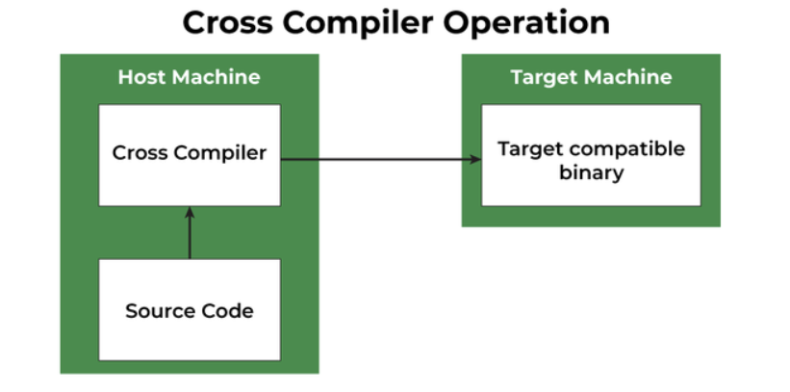
Block Diagram For Cross Compiler.

Uses of Cross Compilers include:
- Embedded Systems Development: Designing software for embedded systems with varying architectures and limited resources.
- Cross-Platform Development: Building applications that can run on multiple platforms without relying on native compilers for each platform.
- Performance Optimization: Using specialised architectures to enhance the performance of software.
- Kernel Development: Compiling operating system kernels for diverse architectures to support different computing environments.

Challenges in Cross Compilation:
- Cross-Platform Testing: Verifying the functionality of cross-compiled binaries on the target platform is essential but may be hindered by limited testing resources and access.
- Library Dependencies: Ensuring that the required libraries are available for the target architecture may be challenging. It requires careful management of dependencies to prevent runtime failures.
- File System Variances: Managing differences in file systems, directory structures, and file naming conventions between the host and target platforms can be a source of complications.
- Toolchain Compatibility: Matching the correct cross-compilation toolchain with the target platform is critical. Incompatibilities can lead to compilation errors and runtime issues

Comparison of Compiler and Cross Compiler:
Feature | Compilers | Cross Compilers
Target Platform | Compiles code for the same platform | Compiles code for a different platform
Use Case | Typically used for native development | Essential for cross-platform development
Debugging Challenges | Debugging is straightforward as it's on the same platform | Debugging can be challenging due to differences in architecture and environment
Example | GCC for compiling C code on a Linux system | GCC configured for compiling code on an ARM-based embedded system from a Linux development machine

Conclusion:
Cross compilers are crucial for making software that can run on different types of computers. They are especially important for things like small embedded systems, making programs that work on various devices, and in special situations. However, setting up cross compilers can be tricky because of the tools they use, and fixing problems in the code can be tough due to differences in how computers are built. Despite these difficulties, cross compilers bring big benefits by saving money and making development smoother. They make it easier to create software that can run on many different kinds of computers and systems.

